Lab Assignment 3.3 – Electricity Bill Generation Using Python & AI Tools

Q1: AI-Generated Logic for Reading Consumer Details

Question
Design a Python program to read consumer details (Previous Units, Current Units, Customer Type) and calculate units consumed.

Prompt
Generate Python code to read previous units, current units, and customer type, then calculate units consumed without using functions.

Code
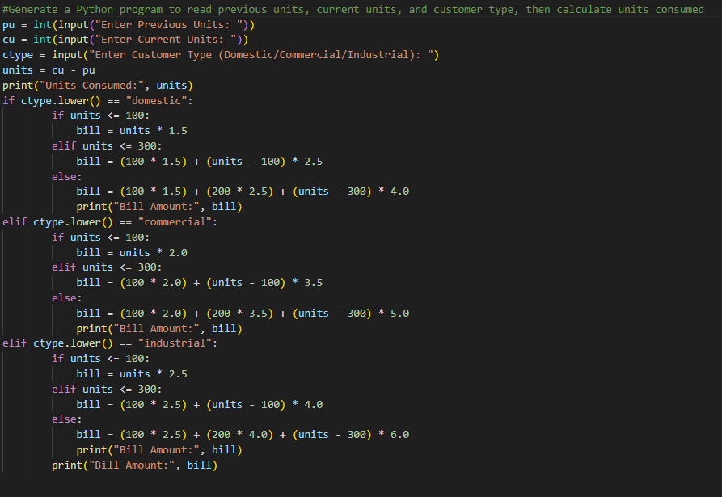

Output

Analysis
Correctly reads inputs. Simple arithmetic for units consumed. No functions used, as required.

Conclusion
The program successfully reads consumer details and calculates units consumed, forming the foundation for billing logic.

Q2: Energy Charges Calculation Based on Units Consumed

Question
Extend Task 1 to calculate Energy Charges (EC) using conditional logic for different customer types.

Prompt
Simplify energy charge calculation logic for Domestic, Commercial, and Industrial customers.

Code

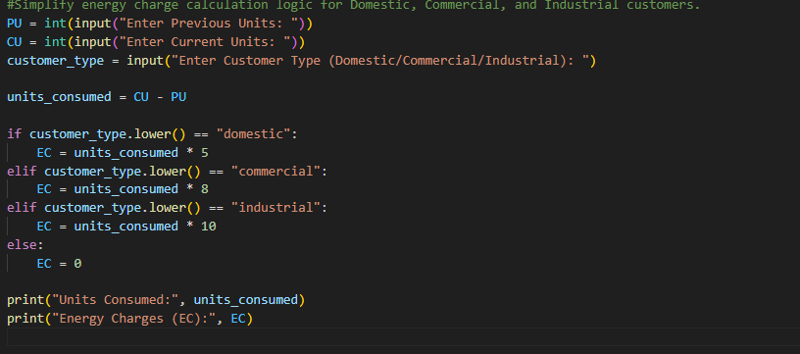Output

Analysis
Uses conditional statements for tariff-based billing. Readability improved with clear structure.

Conclusion
Energy charges are calculated correctly based on customer type, demonstrating conditional logic.

Q3: Modular Design Using Functions

Question
Refactor billing logic into functions for reusability.

Prompt
Generate Python functions to calculate energy charges and fixed charges with comments.

Code
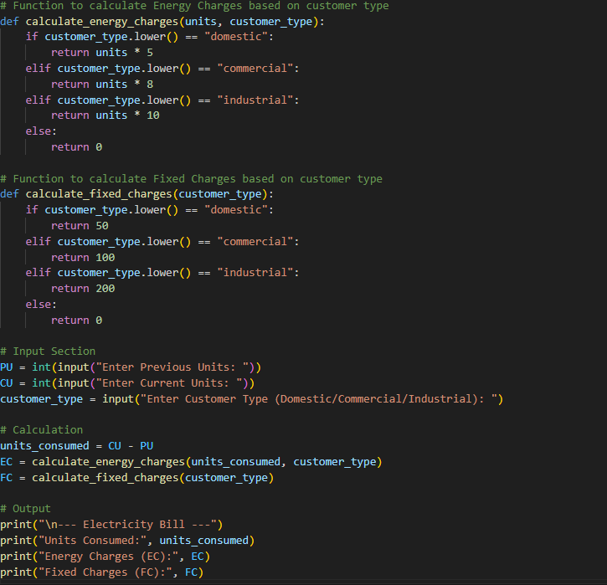

Output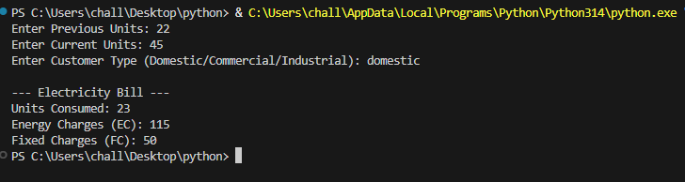

Analysis
Functions improve modularity and reusability. Easier to extend for multiple consumers.

Conclusion
The program now follows modular design principles, making billing logic reusable and maintainable.

Q4: Calculation of Additional Charges

Question
Add Customer Charges (CC) and Electricity Duty (ED).

Prompt
Add electricity duty calculation and customer charges to improve billing accuracy.

Code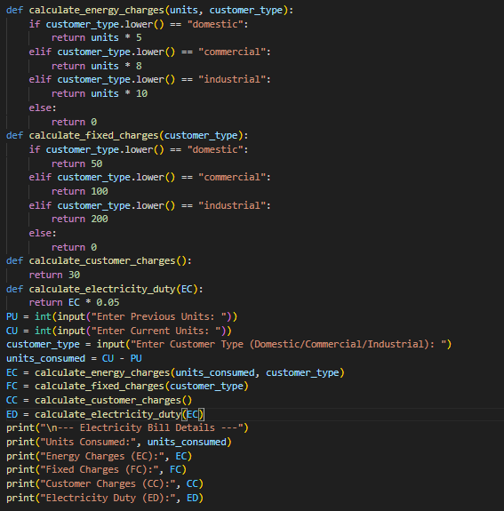

Output
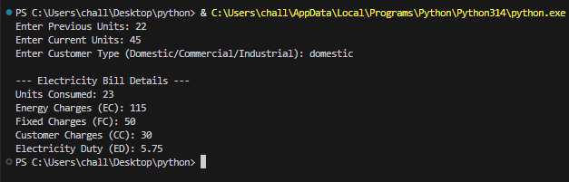

Analysis
Additional charges calculated correctly. Duty percentage applied to EC.

Conclusion
The program now includes all billing components, ensuring accuracy and completeness.

Q5: Final Bill Generation and Output Analysis

Question
Generate the final electricity bill with all components.

Prompt
Generate a complete electricity bill with neatly formatted output.

Code
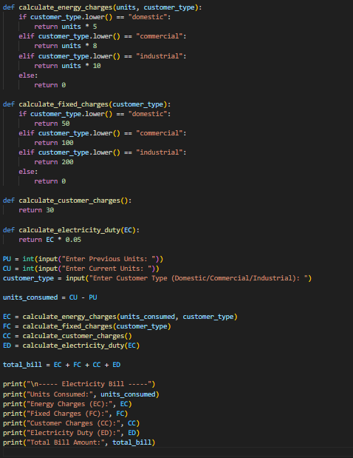

Output
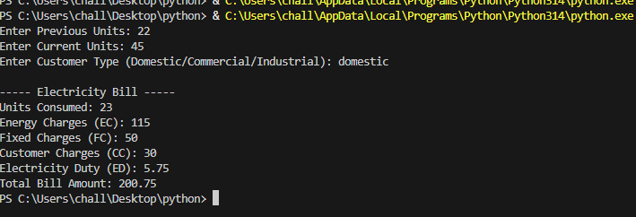

Analysis
Output is neatly formatted. All charges included. Real-world applicability demonstrated.

Conclusion
The final program generates a complete electricity bill with accuracy, readability, and practical relevance.

